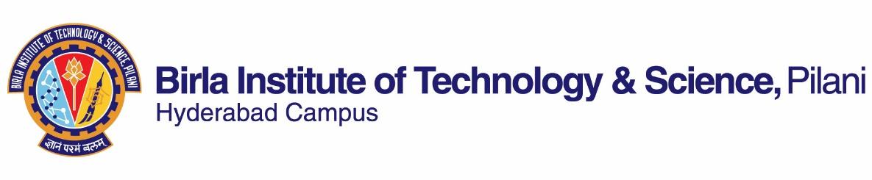

First Semester, 2022-2023

Course Handout (Part II)

29-08-2022

In addition to Part I (General Handout for all courses appended to the Time Table), this portion gives further specific details regarding the course.

**Course No.** : BITS F311

**Course Title**: Image Processing

**Instructor – in - Charge:** Dr. Abhijit Das

**Course Description:** This is a course to envoy knowledge on digital image processing. It begins with an introduction to the fundamentals of digital images and discusses the various discrete transforms, which are extensively used in image processing. It then discusses the different image processing techniques such as color image processing, morphological operation, image enhancement, automatic image classification and recognition.

# Scope & Objectives: The course introduces the students to the fundamentals of digital images and various processing techniques that are applied to them so as to improve their quality. These techniques are image enhancement, automatic image classification and recognition.

The objectives of the course are:

* To provide a comprehensive understanding of the foundational and other essential concepts involved on digital image processing.
* To introduce various discrete transforms, morphological operation, and image enhancement which are extensively used in image processing.
* To introduce the current advancements in image processing such as object recognition and pattern recognition.

**Text Book:** Gonzalez, R. C. & R. E. Woods, Digital Image Processing, Pearson Education, 4th ed., 2016.

**Reference Books:**

1. Algorithms for image processing and computer vision. Parker, Jim R., John Wiley & Sons, 2010.
2. Learning OpenCV 4 Computer Vision with Python 3: Get to Grips with Tools, Techniques, and Algorithms for Computer Vision and Machine Learning, 3rd Edition by Joe Minichino and Joseph Howse, 2020.
3. Deep Learning for Vision Systems, 1st Edition by Mohamed Elgendy, Manning, 2020.

**Course Plan:**

|  |  |  |  |
| --- | --- | --- | --- |
| **Lecture No.** | **Learning Objectives** | **Topics to be covered** | **Chapter in the Text Book** |
| 1 | To introduce fundamental concepts and terms associated with digital images. | Introduction and digital image fundamentals. | Chap 1 and 2 |
| 2-3 | To study image enhancement by gray level transformations | Some basic gray level transformations | Chap 3  Sec. 3.1, 3.2 |
| 4-6 | To study Histogram processing of an image | Histogram processing | Chap 3  Sec 3.3 |
| 7-8 | To learn image enhancement by filtering in the spatial domain | Spatial filtering | Chap 3  Sec. 3.4-3.7 |
| 9-11 | To review the Fourier domain techniques | Fourier Transforms, DFT, Convolution | Chap 4  4.1-4.6 |
| 12-14 | To understand Filtering in the Fourier domain | Image smoothing and sharpening using frequency domain filters | Chap 4  4.7-4.10 |
| 15-17 | To understand Image Restoration and Reconstruction | Noise models, Inverse filtering | Chap 5  5.1-5.7 |
| 18-20 | To understand Color image processing | color fundamental, models, pseudo image processing, color transformation, color smoothing and sharpening, compression | Chap 6  6.1-6.7 |
| 21-24 | To understand Wavelet and other image transform | Slant, Harr and Wavelet transform | Chap 7  7.4-7.7 |
| 25-27 | To understand Image Compression | Basic Compression Methods (DCT) | Chap 8  8.1-8.2 |
| 28-30 | To understand Morphological Image Processing | Erosion, dilation, opening closing, hit-or-miss transformation, some basic morphological algorithms | Chap 9  9.1-9.4, 9.5.1-9.5.7 |
| 31-33 | To understand Image Segmentation | Point, line and edge detection, thresholding | Chap 10  10.1-10.3 |
| 34-36 | To understand Representation and description | Boundary following, chain codes, signatures, boundary descriptors, regional descriptors, principal components analysis (PCA) | Chap 11  11.1.1-11.1.2, 11.1.5, 11.2, 11.3.3,11.3.4, 11.4 |
| 37 – 42 | To understand Object Recognition | Patterns and pattern classes, decision-theoretic methods | Chap 12  12.1-12.8 |

**Evaluation Scheme:**

|  |  |  |  |  |
| --- | --- | --- | --- | --- |
| **Evaluation Component** | **Duration** | **Weightage** | **Date & Time** | **Nature of Component** |
| Mid Semester exam | 90 Minutes | 25% | 31/10 11.00 - 12.30PM | Closed Book |
| Mini Project | ---- | 15% | TBA | Open Book |
| Programing assignment | —- | 15% | TBA | Open Book |
| Comprehensive Examination | 3 Hours | 45% | 17/12 AN | Closed Book |

**Note:** 40% of the evaluation to be completed by midsem grading.

**Chamber Consultation Hour:** To be announced in the class.

**Notices:** Notices concerning the course will be put up on the CMS/Google Classroom website.

**Academic Honesty and Integrity Policy:**

Academic honesty and integrity are to be maintained by all the students throughout the semester and no type of academic dishonesty is acceptable.

**Make-up Policy:** Make-up for mid semester exam and comprehensive exam will be granted **only** on genuine grounds of sickness **(to be supported by a medical certificate and not a prescription**). There is NO makeup for other evaluation components.

**Instructor-in-Charge**

BITS F311